Mertcan Aşgün

63948

Homework 06: Expectation-Maximization Clustering

Our aim was to implement an expectation – maximization clustering algorithm to cluster the data that we will generate. For this purpose, I started with generating the data points with given mean, covariance and size parameters. That is the corresponding figure of the data points:

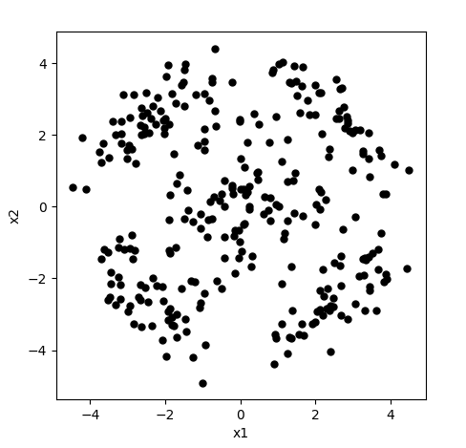

Then, to be able to initialize our EM algorithm, I ran k-means clustering algorithm that implemented in lab 11, 2 times as k is set to 5. Then I set the centroids as means and calculated the covariance and priors corresponding to that mean. Those are the corresponding values:

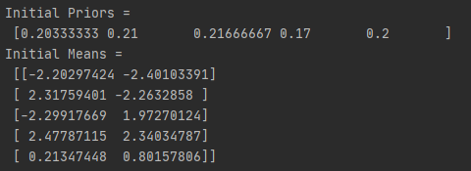

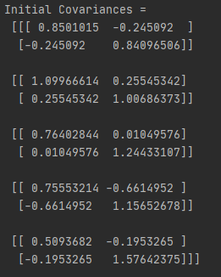

Then by using EM Algorithm (7.14) on the book, and updating means, covariances and priors at each iteration, I ran 100 iterations. The means I got after 100 iteration as follows:

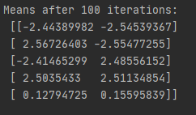

And lastly I plotted the graph of the points and draw the densities for both original parameters and the updated parameters using the pyplot’s contour() method, similar to the homework 1. The graph is as follows:

